JOB SEARCH API INTEGRATION
TEAM ID: PNT2022TMID22972

API registration:
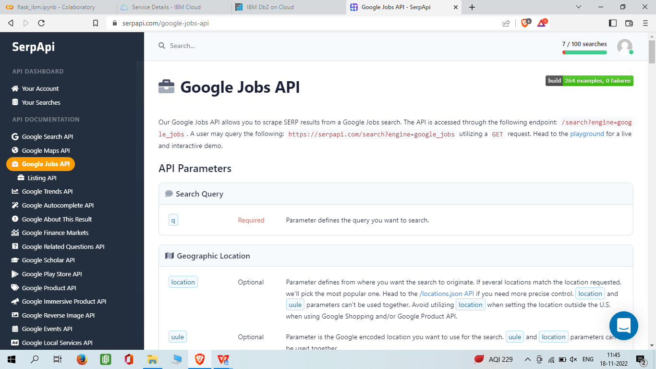

API integration code:
from serpapi import GoogleSearch

params = {
"engine": "google_jobs",
"q": "barista new york",
"hl": "en",
"api_key": "2d444c5f42ee2e27cad08df5c61a8d706cecd33179d1db4fd1dbfe5a358c541a"}

search = GoogleSearch(params)
results = search.get_dict()
jobs_results = results["jobs_results"]
API responses:
